Bsc Information Science Year Three, 2025

Name: Lewis Kariuki

Admission: AIIM/00477/2021

Course: Business plan

**CHAPTER 3: ORGANIZATION/MANAGEMENT PLAN**

3.1 Business Manager

The business manager for KangaPages would mange day to day operations here by ensuring the company runs efficiently. They would be maintaining coordination among different departments ensuring that all projects are completed. These is achieved by being responsible in managing project timelines, budgets, and resources, as well as coordinating with team members and gig workers to ensure project deliverables are met. The Business Manager will develop and implement business strategies to drive growth and profitability, serving as the primary point of contact for clients and stakeholders.

The business manager requirements would be: a Holder of a Degree certification in Business Administration, Management, or a related field, with at least 2 years of experience in business management, preferably in the web development or digital marketing industry. There essential skills would include strong leadership, communication, and organizational abilities, along with proficiency in project management tools such as Zoho, Trello or Asana project management tools and a solid understanding of web technologies and digital marketing strategies.

*Organization chart*

Business Manager

|

---------------------------------------------------------------------------------------------------------

| | | |

Web Development Design Marketing Project Management

| | | |

Front-end Devs UI/UX Designers Social Media Project Coordinators

| | |

Back-end Devs Graphic Designers Email Marketers

| |

Full-stack Devs Content Writers

3.2 Key Personnel

Headed by the business manager the key personnel would be the head of the main departments Web Development, Design, Marketing and the Project Management.

The head of web development will oversee the development team, ensuring high-quality code and managing technical project requirements. This role requires personnel certified in a related field to computer science in web development with proficiency in programming languages such as HTML, CSS, JavaScript, and experience with frameworks like React or Node.js and strong problem-solving abilities are essential for this position.

The head of design will lead the design team, creating appealing design for websites and ensuring visual consistency across projects. This role requires personnel certified in a related field to graphic design along with expertise in design software such as Adobe Creative Suite or Figma, and a strong understanding of UX/UI principles.

The head of marketing will develop and execute marketing strategies that originates form Chapter 2, 2.4 Methods of Advertising and Sales Promotion. They would manage campaigns, and analyze performance metrics. This role requires personnel certified in a related field to Marketing or Business, with experience in digital marketing strategies, SEO, and social media management.

The project manager will assist the business manager in coordinate project timelines, manage client communications, and ensure project milestones are met. This role requires personnel certified in a related field to Project Management along with strong organizational and communication skills and experience with project management tools such as Zoho, Trello or Asana.

3.3 Other Personnel

KangaPages will also engage gig workers for specific projects. They would include;

Web developers gig workers who will work on specific project tasks as assigned by the Head of Web Development. Relevant certifications or degrees in web development are required, along with proficiency in front-end and/or back-end technologies.

UI/UX Designers gig workers would create design assets and prototypes for client projects. Relevant design qualifications or experience are necessary, along with a strong portfolio showcasing design work and user experience projects.

Content Writers gig workers would produce high-quality content for websites and marketing materials. Relevant certification in English, Communications, or a related field is required, along with excellent writing and editing skills and knowledge of SEO best practices.

3.4 Recruitment, Training, and Promotion

KangaPages will source employees and gig workers from word of mouth from past projects or referrals and platforms like like <https://www.guru.com/m/hire/freelancers-in/kenya/>, <https://freelancerkenya.com/> or linkedin as well as local Kenyan job boards such as BrighterMonday and JobWebKenya. The recruitment process will include job postings on relevant platforms, resume screening, interviews, and practical tests or portfolio reviews to assess candidates.

Once hired, employees will be introduced to the company culture and values, training on tools and software used in the business, and ongoing professional development opportunities through workshops and online courses.

Promotions will be based on performance evaluations, skill development, and contributions to the company. Factors considered will include achievement of project goals, leadership capabilities, and the initiative in taking on additional responsibilities.

3.5 Remuneration and Incentive

KangaPages is committed to attracting and retaining top talent in Kenya with a competitive compensation philosophy reflected on the salary schedule.

|  |  |  |  |  |  |
| --- | --- | --- | --- | --- | --- |
| **TITLE** | **AMOUNT (KSH.)** | **ALLOWANCES (KSH.)** | **Daily Rate (KES)** | **DEDUCTIONS (KSH.) i.e Tax, NHIF & NSSF** | **NET MONTHLY PAY (KSH.)** |
| Business Manager | 200000 | $50,000.00 | N/A | $26,000.00 | $224,000.00 |
| Head of Web Development | 150000 | $20,000.00 | N/A | $21,000.00 | $149,000.00 |
| Head of Design | 120000 | $11,000.00 | N/A | $19,500.00 | $111,500.00 |
| Head of Marketing | 130000 | $15,000.00 | N/A | $20,000.00 | $125,000.00 |
| Project Manager | 180000 | $20,000.00 | N/A | $25,000.00 | $175,000.00 |
| Web Developer (Gig Worker) | N/A | N/A | $1,500.00 | N/A | $30,000.00 |
| UI/UX Designer (Gig Worker) | N/A | N/A | $1,200.00 | N/A | $36,000.00 |
| Content Writer (Gig Worker) | N/A | N/A | $1,000.00 | N/A | $30,000.00 |
| **Total** | **1007000** | **$176,000.00** |  | **$141,500.00** | **$925,500.00** |

To motivate employees and maximize productivity, KangaPages will implement both financial incentives like equity share options of the business and bonuses and non-financial incentives which would include remote work options and flexible working hours .

3.6 Legal Requirements.

As KangaPages would operate as an online business it would follow the directions published by jamiitrade <https://jamiitrade.africa/view-post/legal-requirements-for-online-businesses>. KangaPages will ensure compliance to the legal requirements on Kenya by acquiring the required licenses, permits and by-laws required for running an online business. For KangaPages would start as a Sole proprietorship and later expand into a Limited liability company, it would be registered with the Registrar of Business Names for the Sole Proprietorship. Once it has grown into a stand alone business it would be Register with the Registrar of Companies for the Limited Liability Company business registration.

For the licenses, a business license is required to operate legally, to be obtained from the local county government at an estimated cost of KES 20,000 per year. Also a Sales tax permit that is necessary for collecting sales tax, to be obtained from the Kenya Revenue Authority (KRA) at no cost. The required license could be aquired through the online sources; for business permits and licenses <https://eregulations.invest.go.ke/procedure/152?l=en> , and for tax compliance <https://kra.go.ke/images/publications/Taxpayers-Guidelines-Licensing---December-2021.pdf> .

For data protection and privacy collects, processes, and stores personal data of customers through the website KangaPages will adhere to the provisions of the Data Protection Act, 2019. From the Acts requirements we will obtaining consent from data subjects. Implementing appropriate security measures to protect personal data. Providing privacy notices to inform data subjects about data processing practices.

From the Consumer Protection Act, 2012 KangaPages as an online business must comply with consumer protection laws. As KangaPages will act as a brand for this business serving as one of the online business's intellectual property a requirement of protecting all its intellectual property by registering its IP with the Kenya Industrial Property Institute (KIPI).

KangaPages will develop clear terms and conditions for its clients website, outlining their specific key aspects. For its electronic payments, ensure compliance with relevant regulations, such as; Obtaining necessary approvals from the Central Bank of Kenya for payment processing. Complying with the Kenya Information and Communications Act (KICA) provisions on electronic transactions.

3.7 Support Services

KangaPages main support service include banking service provided by Equity Bank for managing finances and transactions. For Legal Services will be provided once arranged by CR Advocates LLP, <https://www.cradvocatesllp.com/practice/internet-law-e-commerce-and-cyberspace-lawyers-in-the-kenya/> . For domain registration and web hosting it woud be provided by TrueHost <https://truehost.co.ke/>. For liability insurance it would be provided by <https://equitygroupholdings.com/ke/insure/sme-small-business/> .

**Chapter 4: Production/Operational Plan for KangaPages**

4.1 Production Facilities and Capacities

For KangaPages operates as an online business in Kenya specializing in custom website development and management the production facilities primarily consist of digital tools and software rather than physical machinery. The following table outlines the essential tools and equipment required for the operation of KangaPages, along with their specifications and costs.

|  |  |  |  |  |  |
| --- | --- | --- | --- | --- | --- |
| **Type of Equipment/Tool** | **Capacity/Function** | **Quantity Required** | **Price per Unit (KES)** | **Total Price (KES)** | **Source Supplier** |
| Computer Systems | Web Development | 5 | 80000 | 400000 | Local Electronics Store |
| Graphic Design Software | Design Creation | 5 Licenses | 15000 | 75000 | Adobe/Canva |
| Project Management Software | Task Management | 5 Licenses | 10000 | 50000 | Zoho/Trello |
| Web Hosting Services | Hosting Websites | 1 | 30000 | 30000 | TrueHost |
| Internet Connection | High-Speed Internet | 1 | 5,000/month | 60,000/year | Local ISP |
| Backup Storage | Data Backup | 1 | 20000 | 20000 | Local Electronics Store |
| **Total=** |  |  | **155000** | **575000** |  |

KangaPages will operate from a home office located in Nairobi CBD which is strategically positioned to access a large pool of potential clients and talent. The office will occupy approximately 200 square feet, providing sufficient space for workstations, meetings, and storage. The layout will include designated areas for Work station (web development, design), meeting/client consultations area, and storage of physical documents.

Business premises layout

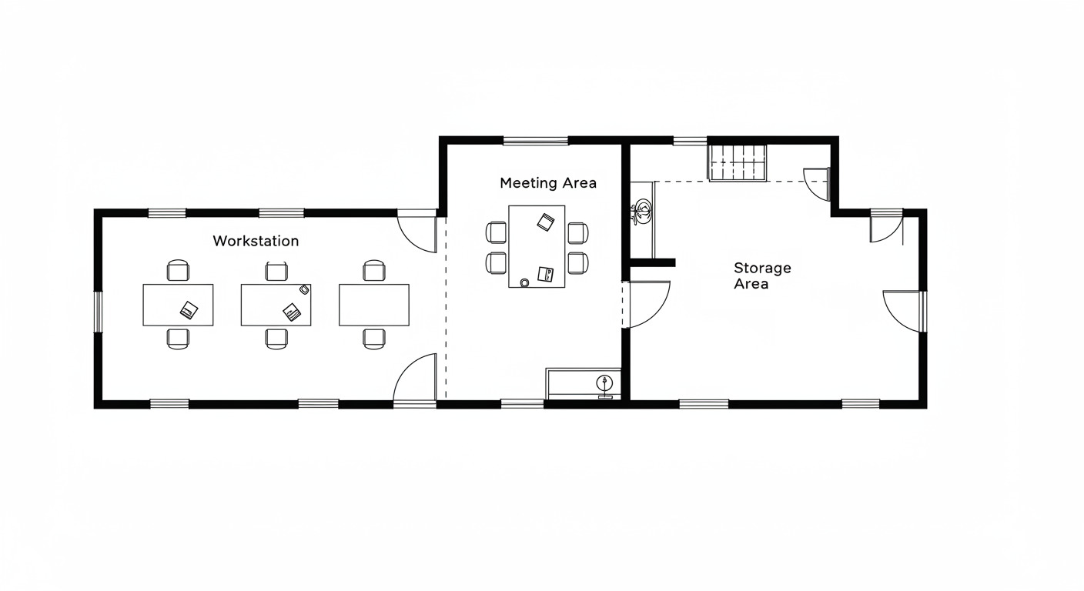

4.2 Production Strategy

KangaPages production strategy focuses on achieving optimal production levels while minimizing costs and maximizing resource utilization. The primary objectives include; Optimum production levels which will be achieved by complete 20 website projects per month, ensuring a steady flow of income and client satisfaction.

Cost efficiency by leveraging open-source tools and software, like wordpress.org which KangaPages will minimize operational costs associated with software licensing and development.

Resource utilization which is achieved by implementing a project management system like Zoho project planning used by the business and project manager who will allow for effective tracking of project timelines, resource allocation, and team performance.

To achieve these objectives, KangaPages will use the following strategies like; Outsourcing specialists by engaging gig workers/freelance web developers and designers for specific projects, allowing for flexibility in resource allocation and workload management. Holding regular training sessions that will be conducted to keep staff updated on the latest web technologies, design trends, and best practices in digital marketing.

KangaPages will implement a maintenance schedule for all software and tools, here by ensuring that they are regularly updated and functioning optimally. Technical support will be sourced from local IT service providers to address any hardware issues that may arise.

The projected monthly costs for KangaPages are as follows;

|  |  |  |
| --- | --- | --- |
| **Cost Category** | **Description** | **Amount (KES)** |
| Materials | Software licenses, hosting fees | 57, 500 |
| Labour | Salaries for full-time staff and freelancers | 925, 500 |
| Production Overheads | Internet, utilities | 30, 000 |
| **Total Monthly Production Cost** |  | **1, 013, 000** |

4.3 Production Process

KangaPages production process is a structured approach to ensure high-quality service delivery which will be done in the following steps;

First client consultation where initial meetings with clients to gather requirements and understand their vision for the website.

Second step will be proposal development where the creation of a detailed proposal that outlines the project scope, timeline, and costs, ensuring transparency and alignment with client expectations.

The third is the design phase where the development of wire frames and design mockups for client approval will be done and incorporate feedback to refine the design.

The fourth step is the development phase where the building of the website using the approved designs in the third step is done. Necessary features such as social media links, analytics, and e-commerce capabilities will be intergreted.

The fifth step is the testing phase which will be conducting thorough alpha and beta testing to ensure the website functions correctly across various devices and browsers, addressing any issues before launch.

The sixth step would be client review. This is when we presenting the completed website to the client for feedback and making necessary adjustments based on their input.

Launch of the website would be the seventh step. By deploying the website and ensuring it is live and accessible through the hosting options provided to users, along with providing the client with training on how to manage their new site.

The eighth and final step would be post launch support where KangaPages would be offering ongoing maintenance and support as per the service agreement, including regular updates and troubleshooting.

4.4 Rules and Regulations Affecting Production

KangaPages must navigate various internal and external factors that could impact its operations. It internal factors would be staff training. By ensuring that all staff are well-trained in compliance with data protection laws and best practices in web development is crucial for maintaining operational integrity.

For its external factors include Government regulations. Compliance with the Data Protection Act, 2019, is essential, as it mandates the protection of personal data collected from clients. KangaPages will implement secure data handling practices to adhere to these regulations.

Business licensing which KangaPages must obtain from the local county government, which is estimated to cost KES 20,000 annually. This license is necessary for legal operation within Kenya. Tax compliance by adherence to the Kenya Revenue Authority regulations for tax collection and remittance is mandatory, ensuring that KangaPages operates within the legal framework.

Compliance with these regulations may increase operational costs due to licensing fees and potential legal consultations. Adhering to data protection laws will require implementing secure data handling practices, which may affect the speed of service delivery. However, these measures are essential for building trust with clients and ensuring the long-term sustainability of KangaPages.